**Airline Reservation Program**

**King Abdulaziz University**

**Faculty of Engineering**

**Department of Industrial Engineering**

**Semester: spring – 2020**

**Section: AA**

|  |
| --- |
|  |

**IE 322: Final project**

**“Airlines Reservation System”**

|  |  |  |
| --- | --- | --- |
| Mem# | Name | ID |
| 1 | Tariq Ziad Hejazi | 1846604 |
| 2 | Salem Rayis | 1849056 |
| 3 | Abdullah Mohammed Al-Frihidy | 1742730 |
| 4 | Rayan Hanafi | 1742327 |
| 5 | Hamed Saegh | 1742754 |

**Date of Submission: 20/4/2020**

**Team:** 15

**Team Members:**

Instructor: DR. Atif

**Table of Contents**

Introduction 3

Contribution in social and economic effect 3

Flow chart: 3

Conclusion 5

Duly checklist 5

Gantt Chart 6

Contribution Table 7

Appendix A (Program video tutorial) 8

Appendix B (Code listing) 8

# Introduction

How beautiful is travelling, especially when we Travel by airplane, airplane is a modern method of transportation which is need an approach to avoid randomly work. Our team work in order to have a systematic approach in airlines reservation system by using visual studio. We did a program in airline reservation system which is more practical and useful for the users. With this program we think the users will not find a difficulty on how to deal with it, because we work on trying to do a useful program to the user. In this assignment we will show the details of this program and we will describe how it is work.

# Contribution in social and economic effect

Many people are trying to save their own time and as we are as engineers there are many ways that we can do to save time. Our project contributes to the society by saving their time and health through submitting their information in this program which will benefit them in submitting it without waiting in a queue and they don’t have to interact with other people that they may cause them some diseases that will threaten their lives. As for the economical factor for the short term as we know now that we are facing problem that is the disease is spreading when people meet each other so this will allow to people to reduce themselves from interfacing each other and doing their things from home rather than going to a reservation office, as for the long term we know that the world is changing through the years by getting more involved in technology and making people life easier.

# Flow chart:

flowchart is a type of diagram that shows the workflow, and it is a step by step way to solve a specific problem. This flow chart will show the approach that we used in coding the program, and it will simplify the main idea of this program. the flowchart will represent our program from the prosses view, so by following the arrows it will be easier to understand the program prosses.

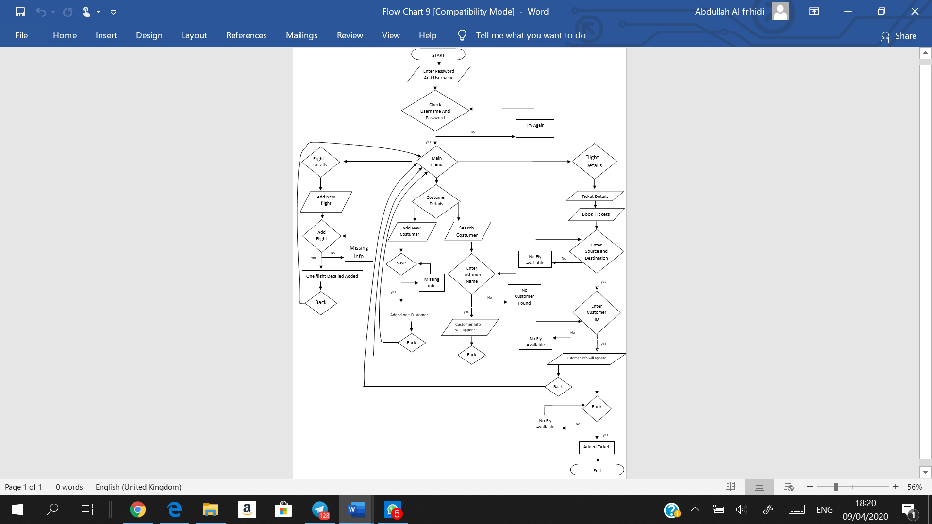

# Conclusion

At the end of the project we will give a brief of what have we done during this project. Since the beginning of covid-19 we were forced to change our projects idea to an idea without a visual models or parts, so we chose an airlines reservation system. This system helps the in the economic aspect and social aspect by saving people time and health through submitting their information in this program which will benefit them in submitting it without waiting in a queue. We programed the system using visual studio by C# programing language as we learned during class. At the end we have benefited and raised our knowledge of programing trough accomplishing this project.

# Duly checklist

|  |  |  |  |
| --- | --- | --- | --- |
| no. | Task | completeness | |
| Yes | No |
| 1 | Follows the format guidelines/template |  |  |
| 2 | Introduction |  |  |
| 3 | Includes Gantt chart |  |  |
| 4 | Includes description of the contribution of each member |  |  |
| 5 | Includes a specific brief on how your project contributes/can contribute to society, academia or public considering any of the social, cultural, economic, health or safety factors |  |  |
| 6 | Includes standard title page with all team member names |  |  |
| 7 | UML diagrams/flow charts of the code are included |  |  |
| 8 | A tutorial-based sample run or example is included |  |  |
| 9 | Conclusion |  |  |
| 10 | Figures/screenshots, Tables and Source-code listings are properly numbers and labelled |  |  |
| 11 | Includes disclaimer/copyright form |  |  |
| 12 | Includes duly filled checklist form |  |  |

# Gantt Chart

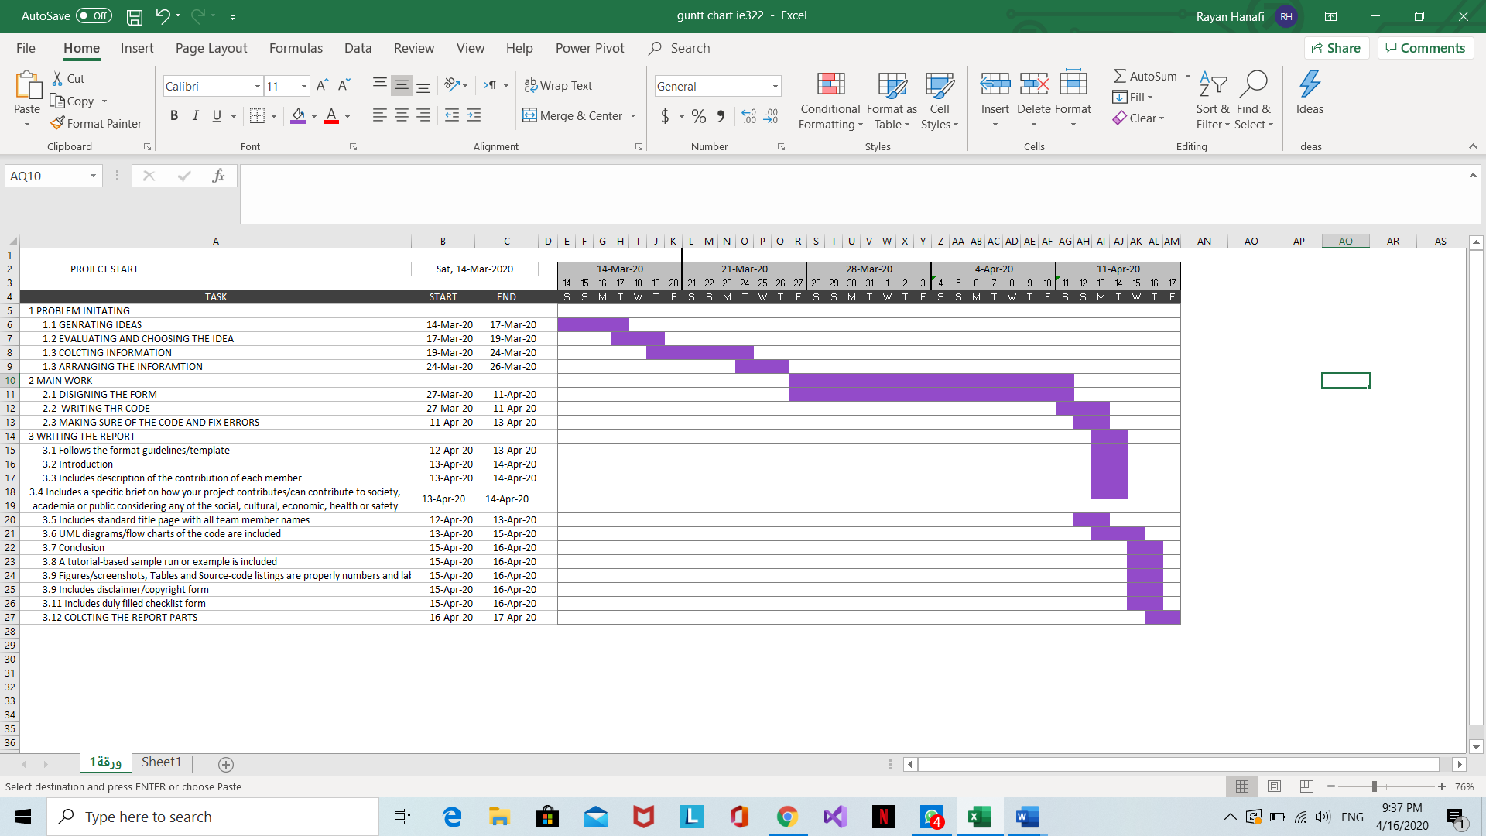

# Contribution Table

|  |  |  |  |  |  |
| --- | --- | --- | --- | --- | --- |
| Task | Rayan Hanafi | Hamed Saegh | Tariq Hejazi | Salem Rayis | Abdullah Al-Frihidy |
| Follows the format guidelines/template |  |  |  |  |  |
| Introduction |  |  |  |  |  |
| Includes Gantt chart |  |  |  |  |  |
| Includes description of the contribution of each member |  |  |  |  |  |
| Includes a specific brief on how your project contributes/can contribute to society, academia or public considering any of the social, cultural, economic, health or safety factors |  |  |  |  |  |
| Includes standard title page with all team member names |  |  |  |  |  |
| UML diagrams/flow charts of the code are included |  |  |  |  |  |
| A tutorial-based sample run or example is included |  |  |  |  |  |
| Conclusion |  |  |  |  |  |
| Figures/screenshots, Tables and Source-code listings are properly numbers and labelled |  |  |  |  |  |
| Includes duly filled checklist form |  |  |  |  |  |

# **Appendix A** (Program video tutorial)



# Appendix B (Code listing)

|  |  |
| --- | --- |
| Data base table Admin |  |
| Data base table Booking |  |
| Data base table Customer _Details |  |
| Data base table Flight _Details |  |
| Form1 | using System;  using System.Collections.Generic;  using System.ComponentModel;  using System.Data;  using System.Drawing;  using System.Linq;  using System.Text;  using System.Threading.Tasks;  using System.Windows.Forms;  namespace airline2  {  public partial class Form1 : Form  {  public Form1()  {  InitializeComponent();  }  private void button1_Click(object sender, EventArgs e)  {  AirlineDbEntities db = new AirlineDbEntities();  if (usrtxt.Text != string.Empty && passtxt.Text != string.Empty)  {  var user = db.Admins.Where(a => a.Username.Equals(usrtxt.Text)).SingleOrDefault();  if (user != null)  {  if (user.Password.Equals(passtxt.Text))  {  Main frm = new Main();  frm.Show();  }  else  {  MessageBox.Show("Wrong Password");  }  }  else  {  MessageBox.Show("Wrong Username");  }  }  else  {  MessageBox.Show("please Fill Username & Password");  }  }  }  } |
| Form 2 | using System;  using System.Collections.Generic;  using System.ComponentModel;  using System.Data;  using System.Drawing;  using System.Linq;  using System.Text;  using System.Threading.Tasks;  using System.Windows.Forms;  namespace airline2  {  public partial class Flight_Details : Form  {  AirlineDbEntities db;  public Flight_Details()  {  InitializeComponent();  db = new AirlineDbEntities();  }  private void button1_Click(object sender, EventArgs e)  {  Flight_Details fd = new Flight_Details();  fd.Flight_Name = flightnametxt.Text;  fd.Source = sourcetxt.Text;  fd.Destination = destinationtxt.Text;  fd.Departure = departuretxt.Text;  fd.Arrival_Time = arrivaltimetxt.Text;  fd.Flight_Class = flightclasstxt.Text;  fd.Flight_Charges = Convert.ToDecimal(flightchargestxt.Text);  fd.Seats = Convert.ToInt16(seatstxt.Text);  db.Flight_Details.Add(fd);  db.SaveChanges();  MessageBox.Show("One Flight Detail Added");  }  private void button2_Click(object sender, EventArgs e)  {  this.DialogResult = DialogResult.OK;  }  }  } |
| Customer | using System;  using System.Collections.Generic;  using System.ComponentModel;  using System.Data;  using System.Drawing;  using System.Linq;  using System.Text;  using System.Threading.Tasks;  using System.Windows.Forms;  namespace airline2  {  public partial class Customer : Form  {  AirlineDbEntities db;  static int id = 0;  public Customer(int ? Id)  {  InitializeComponent();  if (Id!=null)  {  button1.Visible = false;  db=new AirlineDbEntities();  Customer_Details customer = db.Customer_Details.Where(addresstxt => addresstxt.Id == Id).FirstOrDefault();  id = customer.Id;  nametxt.Text = customer.Name;  fathertxt.Text = customer.FatherName;  birthdate.Value = (DateTime)customer.BirthDate;  emailtxt.Text = customer.Email;  phonetxt.Text = customer.Phone;  addresstxt.Text = customer.Address;  }  else  {  button2.Visible = false;  }  }  private void button1_Click(object sender, EventArgs e)  {  AirlineDbEntities db = new AirlineDbEntities();  Customer_Details customers = new Customer_Details  {  Name = nametxt.Text,  FatherName = fathertxt.Text,  BirthDate = birthdate.Value,  Email = emailtxt.Text,  Phone = phonetxt.Text,  Address = addresstxt.Text  };  db.Customer_Details.Add(customers);  db.SaveChanges();  MessageBox.Show("Add one customer");  }  private void button2_Click(object sender, EventArgs e)  {  db = new AirlineDbEntities();  Customer_Details customer = db.Customer_Details.Where(addresstxt => addresstxt.Id == id).FirstOrDefault();  customer.Name = nametxt.Text;  customer.FatherName = fathertxt.Text;  customer.BirthDate = birthdate.Value;  customer.Email = emailtxt.Text;  customer.Phone = phonetxt.Text;  customer.Address = addresstxt.Text;  db.SaveChanges();  MessageBox.Show("Record Updated");  }  }  } |
| Guest | using System;  using System.Collections.Generic;  using System.ComponentModel;  using System.Data;  using System.Drawing;  using System.Linq;  using System.Text;  using System.Threading.Tasks;  using System.Windows.Forms;  namespace airline2  {  public partial class Guest : Form  {  public Guest()  {  InitializeComponent();  }  private void button1_Click(object sender, EventArgs e)  {  AirlineDbEntities db = new AirlineDbEntities();  Customer_Details customers = new Customer_Details  {  Name = nametxt.Text,  FatherName = fathertxt.Text,  BirthDate = birthdate.Value,  Email = emailtxt.Text,  Phone = phonetxt.Text,  Address = addresstxt.Text  };  db.Customer_Details.Add(customers);  db.SaveChanges();  MessageBox.Show("Add one customer");  }  private void button2_Click(object sender, EventArgs e)  {  this.DialogResult = DialogResult.OK;  }  }  } |
| Main | using System;  using System.Collections.Generic;  using System.ComponentModel;  using System.Data;  using System.Drawing;  using System.Linq;  using System.Text;  using System.Threading.Tasks;  using System.Windows.Forms;  namespace airline2  {  public partial class Main : Form  {  public Main()  {  InitializeComponent();  }  private void bookTicketToolStripMenuItem_Click(object sender, EventArgs e)  {  Ticket_Reservation frm = new Ticket_Reservation();  frm.ShowDialog();  }  private void addNewCustomerToolStripMenuItem_Click(object sender, EventArgs e)  {  Guest frm = new Guest();  frm.ShowDialog();  }  private void SearchCustomer_Click(object sender, EventArgs e)  {  Search_Customers frm = new Search_Customers();  frm.ShowDialog();  }  private void addNewFlightsToolStripMenuItem_Click(object sender, EventArgs e)  {  Flight_Details frm = new Flight_Details();  frm.ShowDialog();  }  }  } |
| Search _Customers | using System;  using System.Collections.Generic;  using System.ComponentModel;  using System.Data;  using System.Drawing;  using System.Linq;  using System.Text;  using System.Threading.Tasks;  using System.Windows.Forms;  namespace airline2  {  public partial class Search_Customers : Form  {  public Search_Customers()  {  InitializeComponent();  }  private void Search_Customers_Load(object sender, EventArgs e)  {  AirlineDbEntities db = new AirlineDbEntities();  var items = db.Customer_Details.ToList();  dataGridView1.DataSource = items;  }  private void textBox1_KeyPress(object sender, KeyPressEventArgs e)  {  AirlineDbEntities db = new AirlineDbEntities();  var items = db.Customer_Details.Where(a => a.Name.Equals(textBox1.Text)).ToList();  dataGridView1.DataSource = items;  }  private void dataGridView1_CellClick(object sender, DataGridViewCellEventArgs e)  {  int id = Convert.ToInt32(dataGridView1.SelectedRows[0].Cells[0].Value);  Customer c1 = new Customer(id);  c1.ShowDialog();  }  private void button1_Click(object sender, EventArgs e)  {  this.DialogResult = DialogResult.OK;  }  }  } |
| Ticket Reservation | using System;  using System.Collections.Generic;  using System.ComponentModel;  using System.Data;  using System.Drawing;  using System.Linq;  using System.Text;  using System.Threading.Tasks;  using System.Windows.Forms;  namespace airline2  {  public partial class Ticket_Reservation : Form  {  AirlineDbEntities db;  public Ticket_Reservation()  {  InitializeComponent();  db = new AirlineDbEntities();  BlindSource();  BlindDestination();  }  private void BlindSource()  {  var items = db.Flight_Details.ToList();  SourceCombo.DataSource = items;  SourceCombo.DisplayMember = "Source";  //hrow new NotImplementedException();  }  private void BlindDestination()  {  var items = db.Flight_Details.ToList();  DestinationCombo.DataSource = items;  DestinationCombo.DisplayMember = "Destination";  //hrow new NotImplementedException();  }  private void button2_Click(object sender, EventArgs e)  {  if(SourceCombo.Text!= DestinationCombo.Text)  {  dataGridView1.DataSource = db.Flight_Details.Where(a => a.Source.Equals(SourceCombo.Text) &&a.Destination.Equals(DestinationCombo.Text)).ToList();  }  }  private void button3_Click(object sender, EventArgs e)  {  int id= Convert.ToInt32(customeridtxt.Text);  var item = db.Customer_Details.Where(a => a.Id == id).FirstOrDefault();  custnametxt.Text = item.Name;  fathertxt.Text = item.FatherName;  dateTimePicker1.Value = (DateTime)item.BirthDate;  emailtxt.Text = item.Email;  phonetxt.Text = item.Phone;  addresstxt.Text = item.Address;    }  private void dataGridView1_CellClick(object sender, DataGridViewCellEventArgs e)  {  var flightid = dataGridView1.SelectedRows[0].Cells[0].Value;  flightidtxt.Text = flightid.ToString();  }  private void button1_Click(object sender, EventArgs e)  {  if (Convert.ToInt32(seatnotxt.Text) <= 120)  {  if (AvailableSeat() == true)  {  Booking booking = new Booking();  booking.CustomerId = Convert.ToInt32(customeridtxt.Text);  booking.DateofJourny = dateTimePicker2.Value;  booking.FlightId = Convert.ToInt32(flightidtxt.Text);  booking.Seatno = Convert.ToInt32(seatnotxt.Text);  db.Bookings.Add(booking);  db.SaveChanges();  MessageBox.Show("Add Ticket");  }  else  {  MessageBox.Show("Seat is already booked");  }  }  else  {  MessageBox.Show("Seat Number is less than 120 or equal to 120");  }  }  private bool AvailableSeat()  {  int flightid = Convert.ToInt32(flightidtxt.Text);  int seatno = Convert.ToInt32(seatnotxt.Text);  string dateofjourney = dateTimePicker2.Value.ToString("dd/mm/yyyy");  var item = db.Bookings.Where(a => a.FlightId == flightid && a.Seatno == seatno).FirstOrDefault();  if (item != null)  {  string existsdate = ((DateTime)item.DateofJourny).ToString("dd/mm/yyyy");  if (existsdate == dateofjourney)  return false;  else  return true;  }  else  {  return true;  }  }  private void button4_Click(object sender, EventArgs e)  {  this.DialogResult = DialogResult.OK;  }  }  } |

**Appendix C (Program Interfaces)**

|  |  |
| --- | --- |
| **Form 1** |  |
| **Form 2** |  |
| **Customer** |  |
| **Guest** |  |
| **Main** |  |
| **Search _Customer** |  |
| **Ticket _Reservation** |  |